**Project Week 1 Report**

Group: 2B

(1). Description of the game

We designed a game named “catching star” based on the LEDs. We designed 4 buttons for the product. One is “on/off” button used for turning on and off the game. One is “reset” button used to restarting the game. “Left” and “right” buttons are used for changing the forwarding direction of the snake to left or right in 60 degrees.

After you pressing the “on/off” button, the game will start. You will have a warm-up time. During this period, the LED at the center will light in blue; meanwhile, the lights on the periphery will be lighted one by one with a random starting point. When the circle lighting finished, the end three LEDs will be the snake with the last lighted LED as the head of the snake. The LED at the center would be turned off. And a random LED on the plane will be lighted as the target “star”.

The snake will move forward automatically, you can change the direction of the snake with the “left” and “right” buttons. When you press the “left” (“right”) button, the snake will turn left (right) in 60 degrees. Each time the snake caught a star, another LED will be lighted as the target star and the moving speed of the snake would be increased.

When the speed of the snake is up to a specific value, the snake will move with the specific value. When the snake has caught 20 stars, the difficulty level of the game will be increased. The snake will disappear for one second randomly; you have to control the snake with the memory of the position and the speed of the snake. The LED at the center will be lighted in yellow for 3 seconds in random to be a barrier, if the snake hit the yellow LED, game over; if the snake strike into the periphery wall, game over.

If the snake caught 50 stars, you win the game, the central LED will be lighted in the green; if the snake hit the central barrier or the periphery wall, you loss, the central LED will be lighted in red. You can press “reset” to restart the game or “on/off” to stop playing.

(2).Required elements

|  |  |  |  |  |  |  |  |
| --- | --- | --- | --- | --- | --- | --- | --- |
| element | capacitance | Red LED | RGB LED | wire | R(10K) | R | switch |
| number | 1 | 70(60+10) | 1 | several | 8(6+2) | 11(10+1) | 4 |

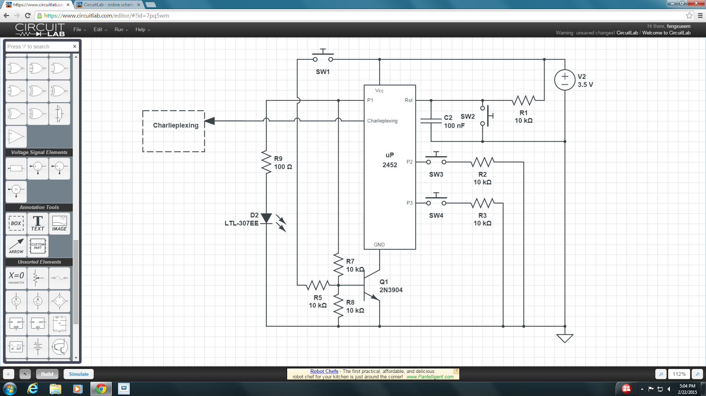(3). Circuit

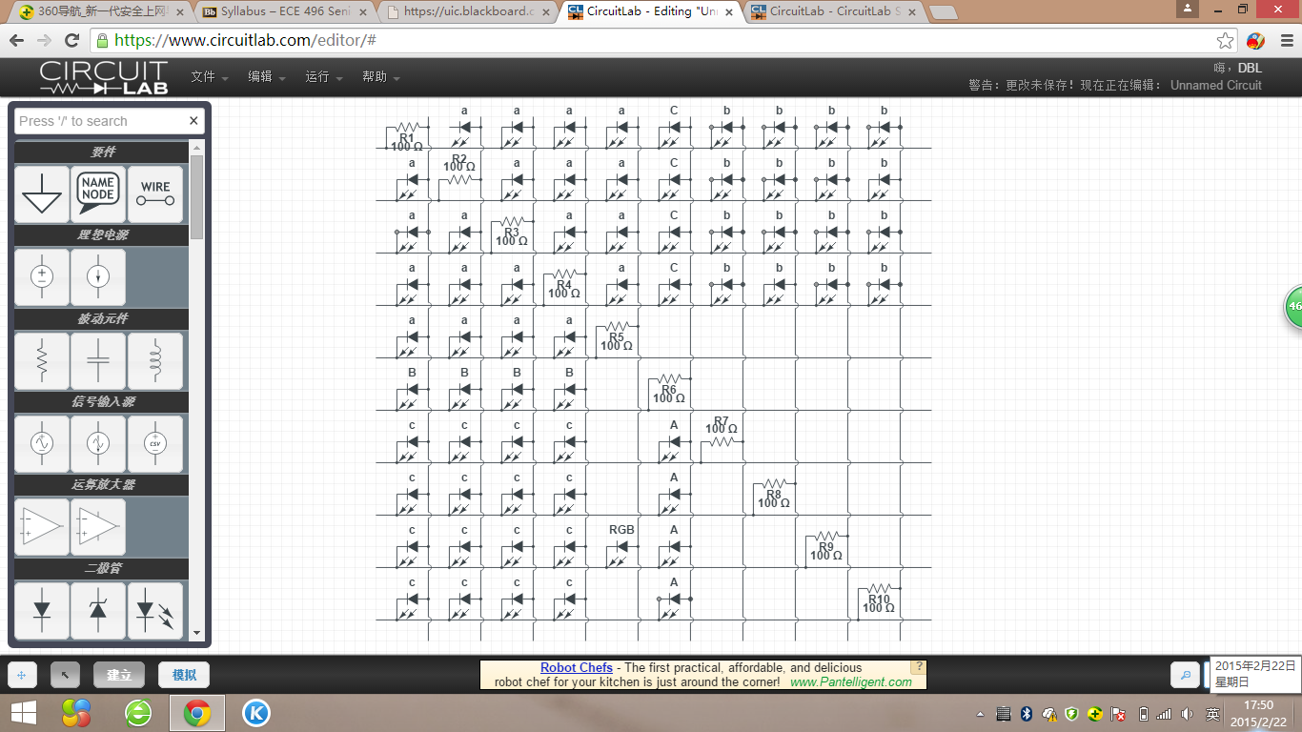

Charlieplexing circuit

Overall circuit